EX:No.8 221501190

Create an ARIMA model for time series forecasting.

Aim:
Write a program to create an ARIMA model for time series forecasting.

Algorithm:
1. Import necessary libraries:
Import numpy, pandas, matplotlib.pyplot, ARIMA from statsmodels.tsa.arima.model, and mean_squared_error from sklearn.metrics.
2. Load the dataset:
Read the weather dataset using pandas.read_csv() and parse the 'Date' column as datetime. Set the 'Date' column as the index.
3. Select the target column:
Extract the 'Temperature' column from the DataFrame for time series forecasting.
4. Split the data:
Calculate the training size as 80% of the total data.
Split the data into training and testing sets using this calculated size.
5. Define and fit the ARIMA model:
Initialize the ARIMA model with training data and set parameters (p=5, d=1, q=0).
Fit the model using .fit().
6. Forecast future values:
Forecast the temperature values for the length of the test set using .forecast().
7.Visualize the training data:
Create a line plot for the training data using matplotlib.
8.Visualize the actual test data:
Create a line plot for the test (actual) data.
9.Visualize the forecasted vs actual test data:
Plot the ARIMA forecast along with the actual test values on the same graph to compare performance.
10.Evaluate the model:
Calculate the Root Mean Squared Error (RMSE) between the forecast and actual test values using mean_squared_error().
11.Print the RMSE value.

Code:
import numpy as np
import pandas as pd
import pandas as pd
import numpy as np
import matplotlib.pyplot as plt
from statsmodels.tsa.arima.model import ARIMA
from sklearn.metrics import mean_squared_error

# Load dataset
df = pd.read_csv(r"/mnt/data/AirPassengers (1).csv", parse_dates=['Month'], index_col='Month')

# Use the passenger count as the time series
time_series = df['#Passengers']

# Split into train and test sets (80% training)
train_size = int(len(time_series) * 0.8)
train, test = time_series[:train_size], time_series[train_size:]

# Fit ARIMA model
model = ARIMA(train, order=(5, 1, 0))
model_fit = model.fit()

# Forecast
forecast = model_fit.forecast(steps=len(test))

# Plot training data
plt.figure(figsize=(10, 4))
plt.plot(train, label='Training Data', color='blue')
plt.title('Training Data')
plt.xlabel('Date')
plt.ylabel('Number of Passengers')
plt.legend()
plt.grid(True)
plt.tight_layout()
plt.show()

# Plot actual test data
plt.figure(figsize=(10, 4))
plt.plot(test, label='Actual Test Data', color='green')
plt.title('Actual Test Data')
plt.xlabel('Date')
plt.ylabel('Number of Passengers')
plt.legend()
plt.grid(True)
plt.tight_layout()
plt.show()

# Plot forecast vs actual
plt.figure(figsize=(10, 4))
plt.plot(test.index, forecast, label='ARIMA Forecast', color='red')
plt.plot(test, label='Actual Test Data', color='green')
plt.title('ARIMA Forecast vs Actual')
plt.xlabel('Date')
plt.ylabel('Number of Passengers')
plt.legend()
plt.grid(True)
plt.tight_layout()
plt.show()

# Calculate RMSE
rmse = np.sqrt(mean_squared_error(test, forecast))
print(f'RMSE: {rmse:.2f}')

Output:

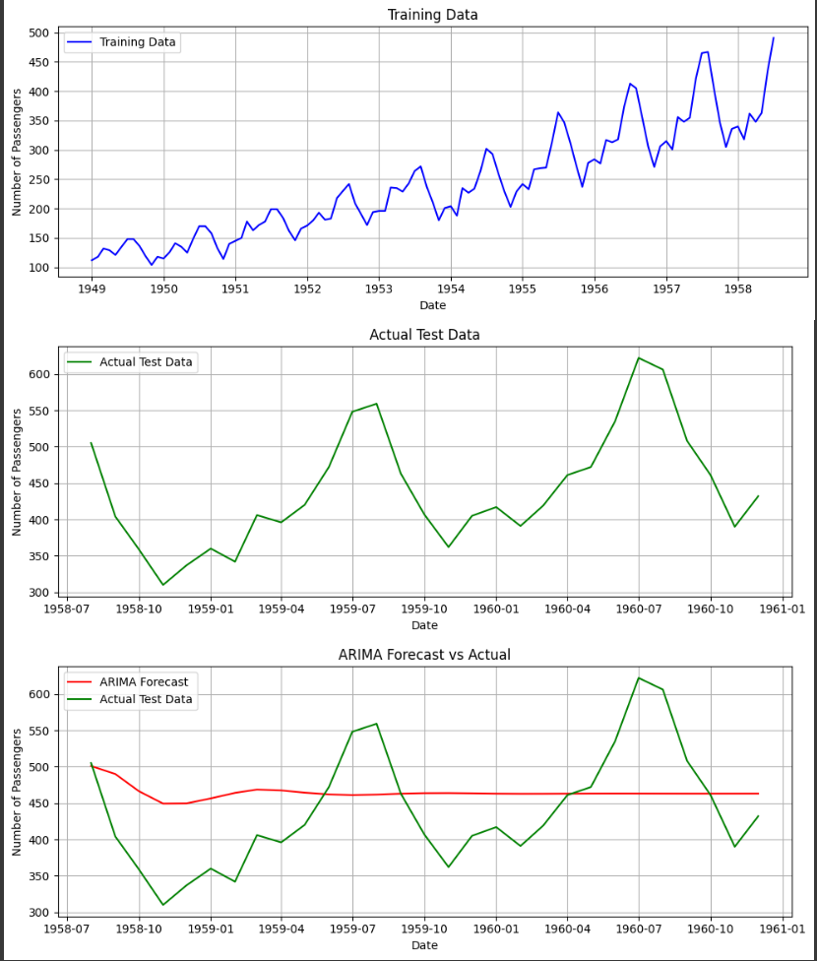

Result:
Thus, the program to create an ARIMA model for time series forecasting was created successfully.

